PROJECT FALCON DOCUMENT-CONTROL UPDATE — 10 SEPTEMBER 2026
STATUS OF THIS COPY: LEGACY / SUPERSEDED REFERENCE. Use BayStation.docx and docs/PROJECT_CONTEXT.md for the current thesis and architecture.
Current pressure-sensor baseline: Holykell HPT604 Type A, provisionally 0–2 mH2O vented gauge with 4–20 mA output, is the recommended long-duration deployment candidate. The exact order code, continuous-saltwater suitability, wetted materials, seal, cable and calibration must be confirmed before purchase. The protected 12 V loop requires a 150 ohm 0.1% shunt, input protection/filtering and a 3.3 V ADS1115 receiver. Bar02 is bench-only; its old I2C PCB and wiring are not fabrication-ready. No hardware is represented as purchased or field-validated.

fProject FALCON: Design and Development of a Solar-Powered Smart Coastal Observation Buoy for Real-Time Wave Monitoring and AI-Assisted Short-Term Wave Height Prediction

Executive Summary
Project FALCON (Fullbright College's AI-powered Live Coastal Observation Network) is a solar-powered Smart Coastal Observation Buoy developed to provide an affordable and autonomous solution for real-time coastal wave monitoring. The system combines Internet of Things (IoT), embedded systems, renewable energy, and Artificial Intelligence (AI) to continuously monitor wave-related conditions and assist users in understanding changing sea conditions.
Many existing marine monitoring systems are expensive and primarily designed for government agencies and large research institutions, making them difficult to deploy in local coastal communities and educational institutions. Most affordable monitoring platforms focus only on collecting and displaying environmental data without providing intelligent analysis that can support timely decision-making.
To address this gap, Project FALCON introduces a low-cost, modular smart buoy capable of measuring wave-related parameters using a focused set of sensors, including an Inertial Measurement Unit (IMU), water pressure sensor, wind speed and wind direction sensors, Global Positioning System (GPS), battery monitoring, and solar power monitoring. These sensors provide continuous environmental data that are processed by an ESP32 microcontroller and displayed through a responsive local web dashboard.
Unlike conventional low-cost monitoring systems, Project FALCON incorporates an AI-assisted Short-Term Wave Height Prediction module that analyzes historical and real-time sensor data to estimate short-term changes in wave height and classify current sea conditions as Calm, Moderate, or Rough. This focused AI capability enhances situational awareness while maintaining a practical and achievable scope for an undergraduate research project.
The current Revision 5 prototype uses a compact single-body marine-grade HDPE main float with a rounded tapered underwater keel, low central ballast, and single-point mooring. A corrosion-resistant frame transfers tower loads to the lower buoy support. Two opposed 30 W solar panels, an MPPT charge controller, and a 12 V LiFePO₄ battery support autonomous operation with practical maintenance access.
Project FALCON aims to provide a cost-effective and locally manufacturable alternative to commercial smart coastal observation buoys while demonstrating the practical integration of IoT, embedded systems, renewable energy, and artificial intelligence. The project is intended to benefit educational institutions, researchers, coastal communities, and local government units (LGUs) by providing accessible technology for real-time coastal monitoring and future environmental research.

Project Background
The Philippines is an archipelagic nation composed of more than 7,600 islands and surrounded by extensive coastal waters that play a significant role in transportation, fisheries, tourism, environmental conservation, and disaster preparedness. Millions of Filipinos depend on coastal resources for their livelihood, making the continuous monitoring of marine conditions an important component of coastal management and public safety. Among the environmental parameters observed in coastal areas, wave conditions are one of the most critical factors influencing fishing operations, small vessel navigation, coastal infrastructure, and emergency response activities.
Despite the importance of coastal monitoring, many local government units (LGUs), educational institutions, and coastal communities have limited access to real-time marine observation systems. Commercial smart buoys capable of monitoring ocean conditions are available; however, these systems are generally designed for large research organizations and government agencies due to their high acquisition cost, specialized maintenance requirements, and proprietary technologies. As a result, many coastal areas, particularly those in developing regions, continue to rely on manual observations or publicly available weather information that may not accurately represent localized sea conditions.
Recent advancements in the Internet of Things (IoT), embedded systems, renewable energy, and artificial intelligence have enabled the development of more affordable environmental monitoring platforms. IoT devices allow sensors to continuously collect and transmit environmental data, while embedded microcontrollers provide efficient local processing. Solar energy further enables autonomous operation in remote coastal locations by reducing dependence on external power sources. These technologies provide an opportunity to design practical and sustainable monitoring systems that are accessible to educational institutions and local communities.
Although numerous studies have explored IoT-based marine monitoring, many existing low-cost systems are limited to collecting and displaying sensor data without providing intelligent interpretation of changing sea conditions. Artificial intelligence has been successfully applied in many environmental monitoring applications; however, its integration into affordable coastal observation buoys remains limited, particularly for short-term wave analysis using real-time sensor data. This creates an opportunity to develop a focused system that not only monitors wave-related parameters but also assists users by estimating short-term changes in wave conditions.
Project FALCON (Fullbright College's AI-powered Live Coastal Observation Network) was conceptualized to address this need by developing a low-cost, solar-powered Smart Coastal Observation Buoy capable of continuously monitoring wave-related environmental conditions while incorporating an AI-assisted Short-Term Wave Height Prediction module. The system integrates a focused set of marine sensors—including an Inertial Measurement Unit (IMU), water pressure sensor, wind speed and wind direction sensors, GPS, battery monitoring, and solar power monitoring—to provide reliable real-time information through a responsive web-based dashboard.
The current prototype is built around a compact single-body marine-grade HDPE float with a rounded tapered underwater keel, low central ballast, and single-point mooring. Sensor data are acquired by an ESP32, while an Orange Pi Zero 3 (4 GB) is the selected local edge computer. The AI workflow uses validated real-time and historical measurements to estimate wave height over a short 5–15 minute horizon and classify sea conditions as Calm, Moderate, or Rough.
By integrating IoT, renewable energy, embedded systems, and a focused artificial intelligence application into a single autonomous platform, Project FALCON aims to provide an affordable and locally manufacturable alternative to commercial smart coastal observation buoys. The project is expected to contribute to coastal monitoring initiatives, support academic research, and serve as a scalable foundation for future developments in intelligent marine observation systems.

3. Problem Statement
Coastal areas play a vital role in the economy, environment, and daily lives of many Filipino communities. Fishermen, coastal residents, researchers, and local government units rely on accurate information about sea conditions to support fishing activities, marine transportation, disaster preparedness, and coastal resource management. Among the different marine parameters, wave conditions are one of the most critical indicators of coastal safety because sudden changes in wave height can directly affect human activities and marine operations.
Although commercial marine observation buoys are capable of monitoring coastal environments, most of these systems are expensive, proprietary, and designed for government agencies or large research institutions. Their high acquisition and maintenance costs make them impractical for widespread deployment in educational institutions and many local coastal communities. As a result, continuous localized wave monitoring remains inaccessible in many areas.
Recent advancements in the Internet of Things (IoT), embedded systems, and renewable energy have enabled the development of lower-cost environmental monitoring systems. However, many existing IoT-based marine monitoring platforms are primarily limited to collecting and displaying sensor data. They often lack intelligent data interpretation that can assist users in understanding short-term changes in wave conditions using the information already collected by the sensors.
Furthermore, most affordable monitoring systems do not combine a stable floating platform, autonomous solar-powered operation, local data processing, and AI-assisted wave analysis into a single integrated prototype. This limits their usefulness as practical and scalable coastal monitoring solutions for educational institutions and local government units.
To address these limitations, Project FALCON proposes the development of a solar-powered Smart Coastal Observation Buoy capable of real-time wave monitoring and AI-assisted short-term wave height prediction using a focused set of IoT sensors. The project aims to provide a practical, low-cost, and locally manufacturable alternative that improves coastal monitoring while maintaining a realistic scope suitable for undergraduate research.

Statement of the Problem
This study aims to design and develop Project FALCON, a solar-powered Smart Coastal Observation Buoy capable of providing real-time wave monitoring and AI-assisted short-term wave height prediction using IoT sensors.
Specifically, this study seeks to answer the following questions:
- How can a solar-powered smart coastal observation buoy be designed and developed to operate autonomously for near-shore coastal monitoring?
- How can IoT sensors be integrated to continuously collect and transmit real-time wave-related environmental data?
- How can an AI-assisted model utilize real-time and historical sensor data to estimate short-term wave height and classify sea conditions as Calm, Moderate, or Rough?
- How can a web-based dashboard effectively visualize real-time wave information, system status, and AI-generated results for users?
- How effective is the developed prototype in terms of:
  - Real-time sensor data acquisition
  - Wave height estimation
  - AI-assisted short-term wave height prediction
  - Sea condition classification
  - Dashboard usability
  - Autonomous solar-powered operation

4. Research Gap
The rapid advancement of Internet of Things (IoT), renewable energy systems, and embedded technologies has enabled the development of intelligent marine monitoring platforms capable of collecting environmental data in real time. Commercial marine observation buoys, such as the Datawell Directional Waverider and NexSens Data Buoy series, have become industry standards for wave monitoring because of their high measurement accuracy and reliability. These systems are widely used for oceanographic research, coastal engineering, and environmental monitoring. However, their acquisition and maintenance costs remain beyond the reach of many educational institutions, local government units (LGUs), and small coastal communities.
Several academic studies have also demonstrated the effectiveness of IoT-based environmental monitoring using microcontrollers such as the ESP32 . These studies successfully collect and transmit environmental data, but most focus primarily on data acquisition and visualization rather than intelligent interpretation of wave behavior. In many cases, artificial intelligence is implemented through cloud computing or requires high-performance computing resources, limiting its practicality for autonomous, low-cost coastal deployments.
Commercial wave buoys such as the Datawell Waverider are capable of measuring wave height, wave direction, and related oceanographic parameters with high precision and have become the benchmark for professional wave measurements. Likewise, NexSens provides modular buoy platforms capable of supporting multiple environmental sensors for coastal and inland water monitoring. While these platforms provide reliable environmental measurements, they are primarily intended for professional research applications and are not designed as affordable educational prototypes using open-source hardware and software.
Based on the reviewed literature and existing technologies, there remains a gap in the development of an affordable, locally manufacturable smart coastal observation buoy that combines real-time wave monitoring with AI-assisted short-term wave height prediction using a focused set of IoT sensors. Existing low-cost systems generally emphasize monitoring and visualization, whereas commercial systems prioritize measurement accuracy at significantly higher cost. Few studies integrate embedded AI, renewable solar power, and a modular mechanical design into a single prototype specifically intended for Philippine coastal environments.
Project FALCON addresses this research gap by developing a solar-powered Smart Coastal Observation Buoy capable of continuously monitoring wave-related conditions while applying an AI-assisted Short-Term Wave Height Prediction model based on real-time sensor fusion. Rather than attempting to solve multiple environmental problems simultaneously, the proposed system focuses on a single, practical innovation: providing affordable real-time wave monitoring with intelligent short-term wave prediction suitable for educational institutions, researchers, and local coastal communities.

manufacturers. These platforms provide accurate environmental monitoring through integrated weather sensors, GPS modules, and satellite communication. However, they are generally expensive and intended for professional research institutions.
Recent academic studies have also demonstrated the use of IoT-based water quality monitoring systems utilizing ESP32, Arduino, Raspberry Pi, and wireless sensor networks. These systems successfully monitor selected environmental parameters but are often limited to laboratory-scale implementations or small freshwater applications.
Artificial intelligence has likewise been applied to environmental prediction, weather forecasting, and anomaly detection. However, most AI implementations rely on cloud computing instead of onboard edge processing suitable for autonomous marine deployments.
Project FALCON combines affordable embedded sensing, two-panel solar power, local edge computing, a maintainable sealed electronics pod, and focused AI-assisted wave analysis in one near-shore research platform.

6. Why Existing Systems Are Not Enough
Although significant advancements have been made in marine monitoring technologies, existing systems continue to present several limitations that restrict their widespread adoption, particularly in educational institutions, small research organizations, and local government units (LGUs). Most commercially available smart buoys are designed for large-scale oceanographic research and industrial applications, emphasizing high-precision measurements and long-term deployment. While these systems provide reliable performance, their high acquisition costs, proprietary technologies, and specialized maintenance requirements make them impractical for many local users.
Commercial wave monitoring systems such as the Datawell Directional Waverider and NexSens Data Buoys are capable of accurately measuring wave parameters and environmental conditions. However, these platforms are primarily intended for professional research applications and often require significant financial investment, trained personnel, and dedicated maintenance. Consequently, they are not easily accessible to educational institutions or coastal communities with limited resources.
On the other hand, many low-cost IoT-based marine monitoring prototypes developed in academic research successfully demonstrate real-time environmental data collection using microcontrollers such as the ESP32, Arduino, and Raspberry Pi. Despite their affordability, these systems commonly focus on monitoring and visualization only. Most do not provide intelligent analysis of collected data, particularly AI-assisted estimation of short-term wave behavior. In addition, many prototypes remain laboratory-scale implementations without considering long-term deployment, mechanical stability, autonomous solar-powered operation, or practical field maintenance.
Another limitation is that several research prototypes attempt to monitor a large number of environmental parameters simultaneously. While comprehensive monitoring provides valuable scientific information, it also increases system complexity, hardware cost, calibration requirements, maintenance effort, and power consumption. Such broad implementations may reduce the practicality of the system for undergraduate research projects and for communities seeking affordable monitoring solutions.
Project FALCON adopts a different design philosophy by focusing on a single core application: real-time wave monitoring with AI-assisted short-term wave height prediction. Rather than integrating numerous environmental sensors and multiple artificial intelligence functions, the proposed system utilizes a carefully selected set of sensors directly related to wave behavior. This focused approach reduces system complexity while maintaining the project's innovative contribution.
By combining renewable solar energy, embedded processing, artificial intelligence, and a modular mechanical design into a cost-effective platform, Project FALCON seeks to provide an accessible alternative that balances affordability, functionality, and practical deployment. The system is intended not to replace high-end commercial oceanographic equipment but to serve as an educational and research-oriented platform capable of supporting localized coastal monitoring and future technological expansion.

Comparison of Existing Systems and Project FALCON
Feature | Commercial Wave Buoys | Typical Low-Cost IoT Prototypes | Project FALCON
Real-time Monitoring | ✅ | ✅ | ✅
Solar Powered | ✅ | Some | ✅
Open-source Hardware | ❌ | ✅ | ✅
Low Cost | ❌ | ✅ | ✅
Modular Design | Limited | Limited | ✅
AI-assisted Wave Analysis | Rare | Rare | ✅
Local Web Dashboard | Limited | Some | ✅
Educational Prototype | ❌ | ✅ | ✅
Designed for Philippine Coastal Deployment | ❌ | Limited | ✅

Key Contribution of Project FALCON
The primary contribution of Project FALCON is not to compete with professional oceanographic buoys, but to demonstrate that an affordable, solar-powered, and locally manufacturable smart buoy can perform real-time wave monitoring while incorporating AI-assisted short-term wave height prediction using embedded IoT technologies. This focused contribution addresses the identified gap between expensive commercial systems and low-cost prototypes that lack intelligent data interpretation.
7. Proposed Solution
Project FALCON proposes the development of a solar-powered Smart Coastal Observation Buoy that provides real-time wave monitoring and AI-assisted short-term wave height prediction using a focused set of Internet of Things (IoT) sensors. The system is designed as an affordable, modular, and locally manufacturable platform that can be deployed in near-shore coastal environments to support marine observation, research, and coastal safety.
Unlike conventional low-cost monitoring systems that only display environmental sensor readings, Project FALCON combines real-time data acquisition, embedded processing, and artificial intelligence to provide additional insight into changing wave conditions. The system continuously gathers wave-related data from a selected set of sensors, processes the information locally, and presents the results through a responsive web-based dashboard accessible over a local wireless network.
The proposed system is composed of four major subsystems:
1. Sensing Subsystem
The sensing subsystem is responsible for collecting real-time environmental and operational data from the buoy. Instead of integrating numerous environmental sensors, Project FALCON focuses only on sensors directly related to wave monitoring and system health. These include:
- BNO085 IMU – measures buoy motion (pitch, roll, and yaw) to detect wave-induced movement.
- Water Pressure Sensor – estimates wave height through pressure variations.
- Wind Speed Sensor – measures surface wind velocity.
- Wind Direction Sensor – determines wind direction.
- GPS Module – provides buoy location for monitoring and recovery.
- Battery Monitor – measures battery voltage, current, and remaining capacity.
- Solar Monitor – monitors solar charging performance.
- Internal Temperature Sensor – monitors the temperature of the electronics enclosure.
This focused sensor configuration reduces hardware complexity while maintaining the information required for wave monitoring and AI analysis.

2. Embedded Processing Subsystem
The embedded processing subsystem is centered on the ESP32 microcontroller, which serves as the primary controller of the buoy. It is responsible for:
- Reading sensor values
- Performing initial data filtering
- Monitoring battery and solar status
- Managing local wireless communication
- Hosting the local web dashboard
- Providing REST API endpoints
- Forwarding processed sensor data to the onboard Orange Pi Zero 3
The ESP32 enables low-power operation while supporting real-time data acquisition and communication.

3. AI Processing Subsystem
Artificial intelligence processing is performed locally using an onboard Orange Pi Zero 3. Unlike cloud-based AI systems, the Orange Pi Zero 3 processes sensor data directly on the buoy, allowing the system to continue operating even without an Internet connection.
The AI module has a single focused responsibility:
- Estimate short-term wave height using historical and real-time sensor data.
- Classify the current sea condition into one of three categories:
  - Calm
  - Moderate
  - Rough
This focused implementation ensures that the AI component remains practical, explainable, and feasible within the scope of an undergraduate research project.

4. Monitoring and Visualization Subsystem
The processed data are displayed through a responsive web-based dashboard hosted locally by the system. Users connected to the buoy's wireless network can access the dashboard using smartphones, tablets, or laptops without requiring an Internet connection.
The dashboard displays:
- Current Wave Height
- Predicted Wave Height
- Sea Condition Classification
- Wind Speed
- Wind Direction
- GPS Location
- Battery Status
- Solar Charging Status
- Internal Temperature
- System Alerts
- AI Prediction Confidence
The interface is designed to provide clear and intuitive visualization of wave conditions while allowing users to monitor the overall health of the buoy.

Proposed System Workflow
Sunlight
│
▼
Solar Panel Array
│
▼
MPPT Charge Controller
│
▼
12V LiFePO₄ Battery
│
▼
Power Distribution Board
│
┌─────────┴─────────┐
▼ ▼
ESP32 Controller Orange Pi Zero 3 (AI)
│ │
▼ │
IoT Sensors ───────────►│
│ │
└──────────┬────────┘
▼
Local REST API
▼
Web-Based Dashboard
▼
User (Phone / Laptop)

Advantages of the Proposed System
Compared with existing low-cost monitoring systems, Project FALCON offers the following advantages:
- Affordable and locally manufacturable design
- Autonomous operation using solar energy
- Focused sensor architecture for wave monitoring
- AI-assisted short-term wave height prediction
- Local web dashboard without requiring Internet connectivity
- Modular hardware and software architecture
- Expandable design for future enhancements
Unlike commercial oceanographic systems, Project FALCON prioritizes accessibility and educational value while still demonstrating the integration of IoT, embedded systems, renewable energy, and artificial intelligence into a practical coastal monitoring solution.

8. General Objective
The general objective of this study is to design and develop Project FALCON, a solar-powered Smart Coastal Observation Buoy capable of real-time wave monitoring and AI-assisted short-term wave height prediction using Internet of Things (IoT) technology and embedded systems.

9. Specific Objectives
Specifically, this study aims to:
- Design and fabricate a stable, solar-powered smart coastal observation buoy suitable for near-shore deployment.
- Develop an IoT-based monitoring system using an ESP32 microcontroller to acquire and process real-time wave-related sensor data.
- Implement an AI-assisted model capable of estimating short-term wave height and classifying sea conditions into Calm, Moderate, or Rough based on real-time sensor inputs.
- Develop a responsive web-based dashboard for visualizing wave conditions, AI predictions, GPS location, battery status, and overall system health.
- Evaluate the performance of the developed prototype in terms of sensor accuracy, AI prediction performance, dashboard functionality, communication reliability, and autonomous solar-powered operation.

10. Scope and Delimitation
Scope of the Study
This study focuses on the design, development, and prototype implementation of Project FALCON, a solar-powered Smart Coastal Observation Buoy intended for near-shore coastal monitoring within approximately one kilometer from the shoreline.
The prototype is designed to monitor wave-related environmental conditions using a focused set of IoT sensors integrated into a single autonomous platform.
The study includes the development of the following components:
Hardware
- Solar-powered electrical system
- ESP32 microcontroller
- Orange Pi Zero 3 (4 GB) for local edge processing
- Revision 5 single-body marine-grade HDPE floating platform
- Rounded tapered underwater keel
- Corrosion-resistant lower-to-main structural support frame
- Adjustable low central ballast system
- Single-point mooring and anchor system

Sensors
The prototype integrates the following sensors:
- BNO085 IMU (SPI)
- Blue Robotics Bar02 water-pressure sensor (I²C)
- Wind-speed sensor
- Wind-direction sensor through ADS1115 ADC
- GPS module (UART)
- INA260 battery monitor
- Second INA260 solar monitor
- MCP9808 electronics-enclosure temperature sensor
Optional sensor
- Sealed DS18B20 water-temperature sensor

Artificial Intelligence
The AI component is limited to:
- Short-Term Wave Height Prediction
- Sea Condition Classification
Possible classifications:
- Calm
- Moderate
- Rough
The AI analyzes real-time and historical sensor data collected by the buoy.

Dashboard
The study includes the development of a responsive local web dashboard capable of displaying:
- Current Wave Height
- Predicted Wave Height
- Sea Condition
- Wind Speed
- Wind Direction
- GPS Location
- Battery Status
- Solar Charging Status
- Internal Temperature
- System Alerts

Power System
The prototype operates using renewable solar energy through:
- Two opposed 30 W solar panels
- MPPT Charge Controller
- 12V LiFePO₄ Battery
allowing autonomous operation without continuous external power.

Delimitation of the Study
The following features are outside the scope of this study:
- Long-range offshore deployment
- Satellite communication
- Mobile application development
- Multi-buoy networking
- Tsunami prediction
- Earthquake prediction
- Weather forecasting
- Ocean current prediction
- Autonomous navigation
- Automatic anchor deployment
- Cloud-based AI processing
- Commercial manufacturing
- Large-scale deployment
- Long-term oceanographic validation using multi-year datasets
Additional water-quality sensors, including pH, salinity, turbidity, and dissolved oxygen sensors, are not included in the initial prototype and are recommended as future enhancements.
Similarly, future developments may include cloud synchronization, LTE communication, satellite connectivity, mobile applications, and additional artificial intelligence capabilities once sufficient field data become available.

11. Significance of the Study
Project FALCON offers significant contributions to multiple sectors.
Educational Institutions
The project demonstrates the integration of IoT, artificial intelligence, renewable energy, embedded systems, networking, and mechanical design into a single interdisciplinary platform that can be used for research and academic instruction.
Coastal Communities
Real-time environmental monitoring provides valuable information regarding changing sea conditions, supporting safer fishing activities and increased environmental awareness.
Local Government Units (LGUs)
The system may assist LGUs in coastal monitoring, disaster preparedness, marine resource management, and environmental conservation.
Researchers
Project FALCON provides a modular research platform capable of supporting future studies in environmental monitoring, artificial intelligence, renewable energy, and embedded systems.
Future Developers
The modular architecture allows future researchers to integrate additional sensors, AI algorithms, communication technologies, and cloud services without redesigning the entire system.

12. Innovation and Uniqueness of Project FALCON
Project FALCON introduces several innovations that distinguish it from existing marine monitoring systems.
Low-Cost Smart Buoy
Unlike expensive commercial smart buoys, Project FALCON prioritizes affordability by utilizing locally available materials and open-source technologies.
AI-Ready Architecture
The system supports a focused onboard AI workflow for 5–15 minute wave-height prediction and Calm, Moderate, or Rough sea-condition classification.
Renewable Solar Energy
Continuous autonomous operation is achieved through an integrated solar-powered energy system.
Modular Mechanical Design
The current Revision 5 buoy uses a compact single-body HDPE float, rounded tapered underwater keel, low central ballast, single-point mooring, and a corrosion-resistant load path from the lower buoy frame to the tapered equipment tower.
Real-Time Monitoring Dashboard
A responsive web dashboard enables users to monitor environmental conditions, battery health, GPS location, and future AI predictions from a centralized interface.
Expandable Platform
Future support for cloud computing, mobile applications, multiple interconnected buoys, AI prediction, and satellite communication can be added without redesigning the system architecture.
SYSTEM ARCHITECTURE
13. System Architecture
Overview
Project FALCON follows a modular layered architecture that integrates embedded systems, renewable energy, artificial intelligence, mechanical engineering, and web technologies into a single autonomous coastal monitoring platform. Each subsystem performs a dedicated function while communicating with other modules through structured data flow.
The architecture consists of five major layers:
- Environmental Sensing Layer
- Embedded Processing Layer
- AI Processing Layer
- Communication Layer
- User Interface Layer
This modular architecture improves maintainability, scalability, and future system expansion while minimizing redesign during hardware upgrades.

14. Overall System Flow
Figure 1. Current local-first workflow: sensing, ESP32 acquisition, Orange Pi edge processing, and dashboard presentation.
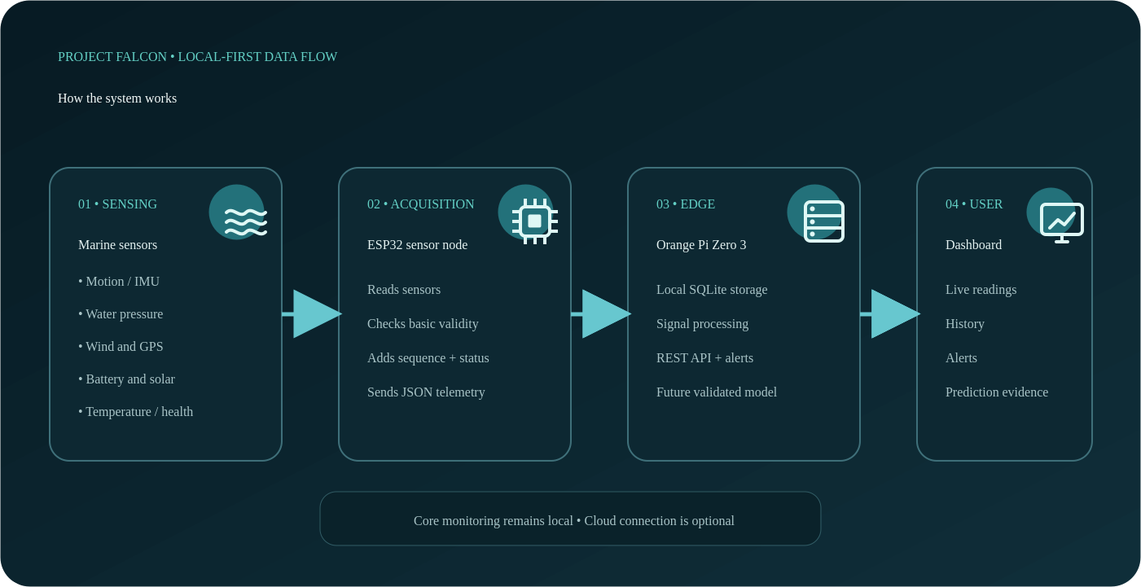

15. Mechanical Architecture
The Revision 5 mechanical subsystem provides buoyancy, self-righting support, waterproof protection, and a continuous structural load path for the elevated electronics, solar, and sensor assemblies.
The current floating platform consists of:
Revision 5 Main Float
- Marine-grade HDPE single-body floating structure
- Nominal outside diameter: 650 mm
- Cylindrical body height: 380 mm
- Rounded tapered underwater keel depth: 240 mm
Stability and Structural System
Stability is provided by the single-body float geometry, rounded tapered keel, adjustable low central ballast, and controlled single-point mooring configuration.
The current arrangement is intended to:
- Lower the center of gravity
- Support self-righting behavior
- Reduce the deployed footprint
- Transfer tower loads into the lower buoy frame
- Support the elevated electronics and sensor tower
Structural Support Frame
Material:
- Marine-grade corrosion-resistant metal, subject to final fabrication selection
Function:
- Connect the lower buoy support to the main frame
- Carry tower, pod, solar-panel, and sensor loads
- Provide corrosion-resistant reinforcement for the marine environment
Ballast System
An adjustable ballast positioned below the rounded keel lowers the center of gravity. Its final mass and position require controlled flotation, heel, and roll-recovery testing.
Marine Anchor
A single-point mooring line connects the buoy to its anchor while permitting controlled response to tides and waves. Final deployment requires verified mooring-load and recovery procedures.
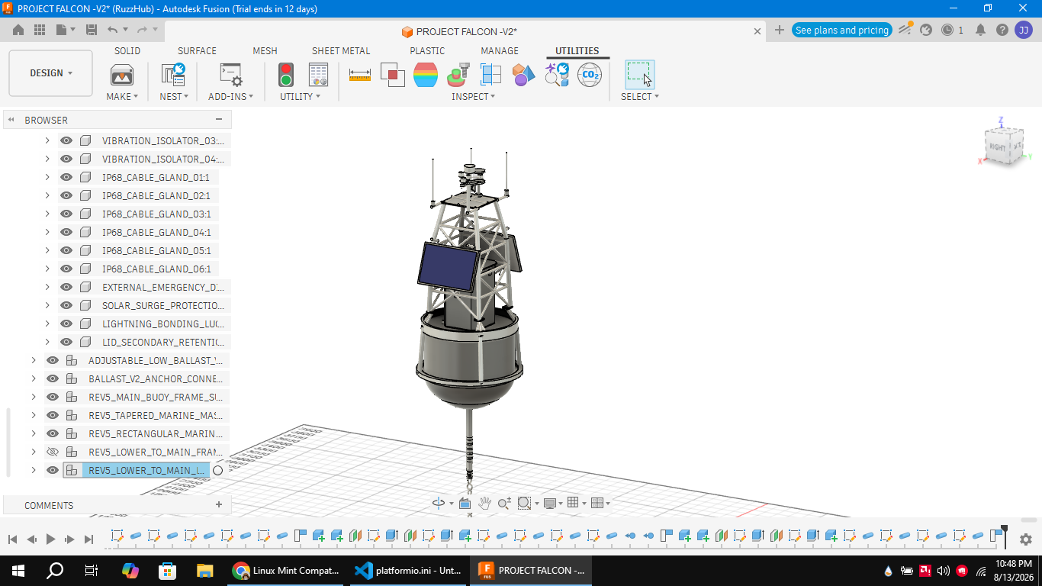
Figure 2. Actual Project FALCON-01 V2 Fusion assembly showing the single-body float, rounded keel, tower, opposed solar panels, and sensor deck.
16. Hardware Architecture
The hardware architecture consists of interconnected embedded systems responsible for sensing, processing, communication, and power management.
Main Controller
ESP32 DevKit
Responsibilities:
- Sensor acquisition
- Local processing
- Wi-Fi Access Point
- Local dashboard
- REST API
- Device monitoring

Edge Computer
Orange Pi Zero 3 (4 GB), selected; physical integration pending
Responsibilities:
- Local AI-assisted wave analysis
- Local database
- Data logging
- Local dashboard and REST API hosting
- 5–15 minute wave-height prediction and sea-state classification

Power Management
Power Source:
Two Opposed 30 W Solar Panels
↓
MPPT Charge Controller
↓
12V LiFePO₄ Battery
↓
Power Distribution Board
↓
Electronics

Sealed Electronics-Pod Thermal System
The current design keeps the electronics pod sealed from salt air and spray while circulating internal air across component heat sinks and a rear thermal-transfer path.
Internal Recirculation
Two internal fans move enclosure air across the electronics and heat sinks; they do not exchange outside air directly.
Thermal components:
- Horizontal component heat sinks
- Vertical thermal bridge
- Internal airflow guides and recirculation fans
Purpose:
Move heat from electronic components toward the sealed rear heat-transfer assembly.

External Heat Rejection
The rear external finned heat sink releases conducted heat to ambient air without opening the enclosure.
Protection:
- Front maintenance door with raised sealing lip
- Dual EPDM gasket barriers and compression latches
- Marine-protected cable entries and corrosion-resistant hardware
Purpose:
Maintain serviceability while limiting saltwater ingress; thermal and ingress performance must still be validated by test.
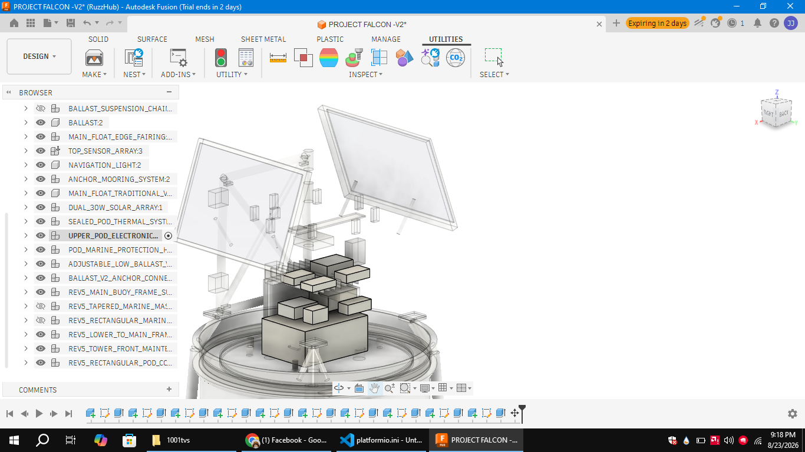
Figure 3. Actual V2 Fusion electronics placement inside the elevated rectangular marine pod.
17. Sensor Architecture
Project FALCON uses a focused Phase 1 sensor set directly related to wave measurement, position, wind, power, and enclosure temperature.
Wave and Motion Sensors
- BNO085 IMU (SPI)
- Blue Robotics Bar02 water-pressure sensor (I²C)
- GPS module (UART)
- Optional sealed DS18B20 water-temperature sensor
- Pressure baseline and motion calibration are required before reporting wave height.

Wind Sensors
- Wind-speed sensor
- Wind-direction sensor
- ADS1115 ADC for wind-direction input
- Wind hardware selection and calibration remain subject to physical validation.
- The Phase 1 prototype does not include a general humidity or weather-station sensor suite.

Orientation and Position
- BNO085 orientation and calibrated buoy motion
- GPS location and UTC timing
- Bar02 pressure variation for wave-estimation research

Power and Thermal Sensors
- INA260 battery voltage and current
- Second INA260 solar voltage and current
- MCP9808 electronics-enclosure temperature
- Optional DS18B20 water temperature

System-Health Inputs
- Sensor validity, freshness, and sequence status
- Internal enclosure temperature
- Battery and solar electrical status
- GPS time and local system timestamps
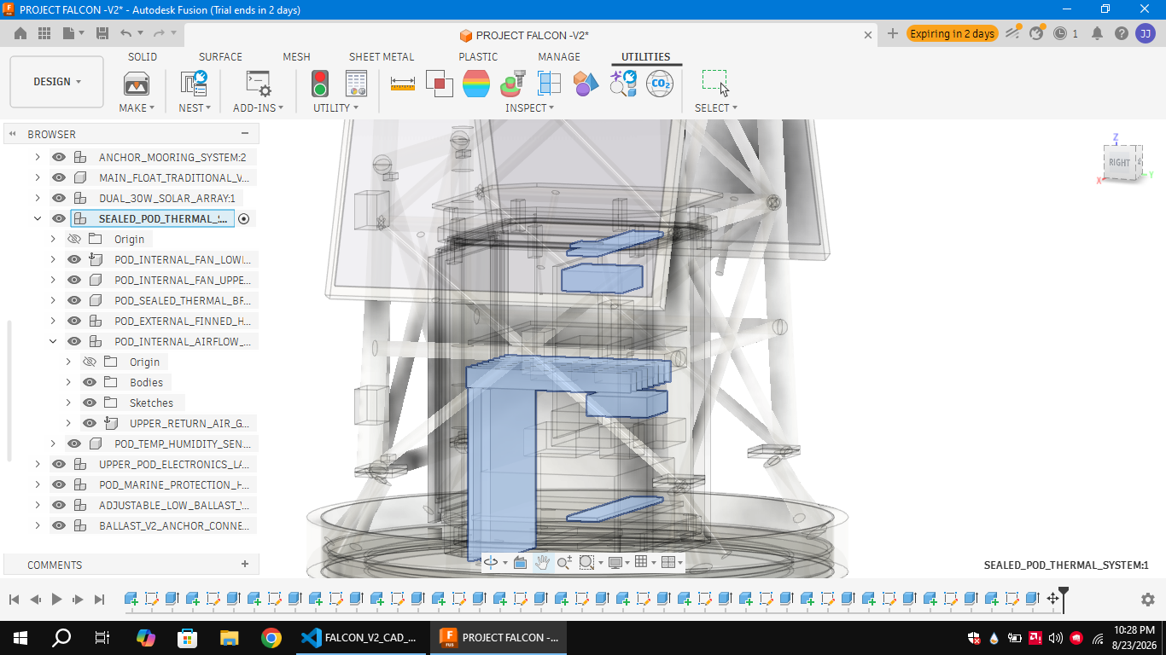
Figure 4. Actual sealed-pod thermal assembly: two internal recirculation fans, component heat sinks, airflow guides, vertical thermal bridge, and rear external finned heat sink.
18. Software Architecture
The software architecture follows a layered design.
Firmware Layer
Runs on ESP32.
Responsibilities:
- Read sensors
- Control hardware
- Monitor battery
- Handle communication

Backend Layer
Runs on the Orange Pi Zero 3 target; a development laptop currently represents this role where hardware integration is incomplete.
Responsibilities:
- Store sensor data
- AI processing
- Local API
- Dashboard backend

Dashboard Layer
Displays:
- Live Sensor Values
- Battery Health
- Solar Status
- GPS Position
- AI Status
- System Health
- Alerts

19. Communication Architecture
The communication system allows seamless interaction between hardware and users.
Internal Communication
Sensors
↓
ESP32
↓
Orange Pi Zero 3 / Development Edge Host

External Communication
Orange Pi Zero 3 / Development Edge Host
↓
Web Dashboard
↓
User Device
Future:
↓
Cloud Server
↓
Mobile Application
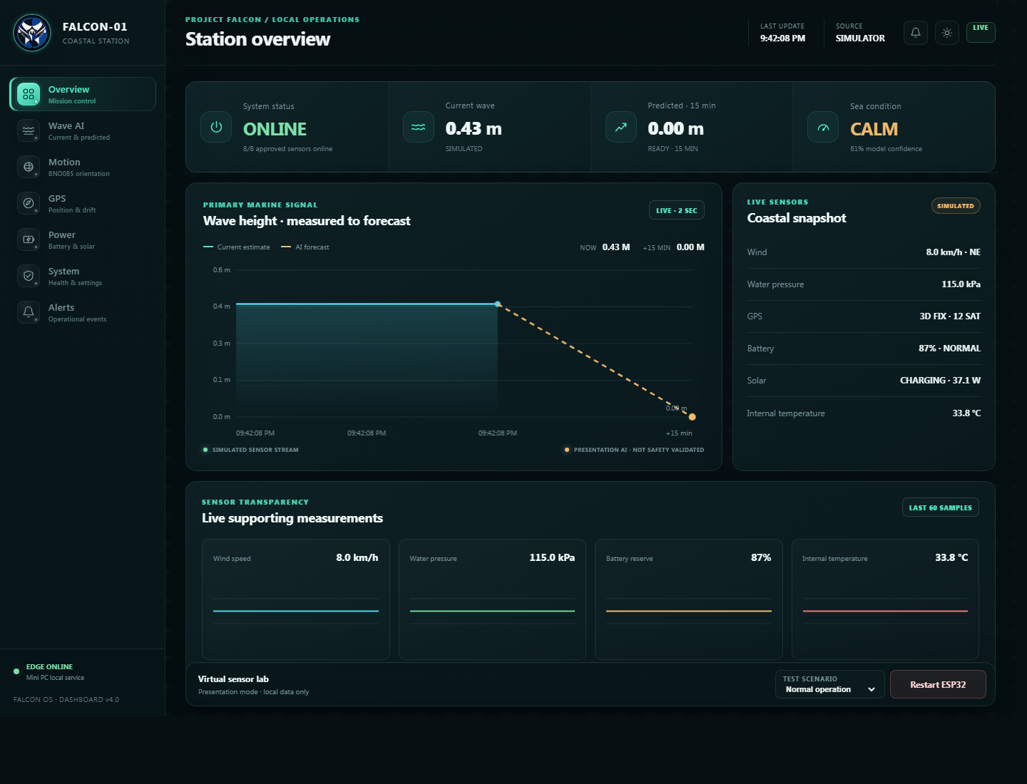
Figure 5. Current Dashboard Next interface for live measurements, wave forecast, sea-condition class, power status, GPS, and system health.
20. Artificial Intelligence Architecture
The focused AI workflow receives validated, time-aligned measurements from the ESP32 data pipeline. Phase 1 limits AI use to short-horizon wave-height prediction and sea-condition classification.
Primary AI Inputs
- Calibrated BNO085 motion features
- Bar02 pressure-derived wave features
- Wind speed
- Wind direction
- Recent observed wave-height history
- Timestamps and sampling quality
- GPS position for record context
- Battery and solar status for data-quality context
- MCP9808 enclosure temperature for system context
- Validated missing-data and stale-data flags
- The model must not use uncalibrated raw acceleration as direct wave height.
- Inputs are accepted only after timestamp, range, and quality checks.
AI Outputs
- Predicted wave height for a 5–15 minute horizon
- Sea-condition classification: Calm, Moderate, or Rough
- Prediction confidence or uncertainty indicator
- Input-quality and insufficient-history status
- Explainable contributing-feature summary when implemented
- The AI does not claim tsunami, earthquake, tide, or general weather forecasting.
- The current dashboard trend predictor is a presentation baseline and is not yet a field-trained or safety-validated oceanographic model.
Model accuracy, calibration, and uncertainty must be evaluated using synchronized field observations and an appropriate reference instrument before operational claims are made.

